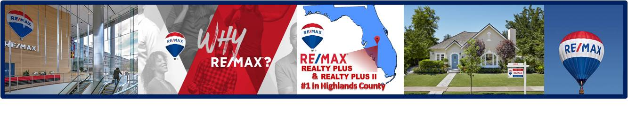

**Highlands County*,***

**Avon Park**

**Sebring**

**Lake Placid**

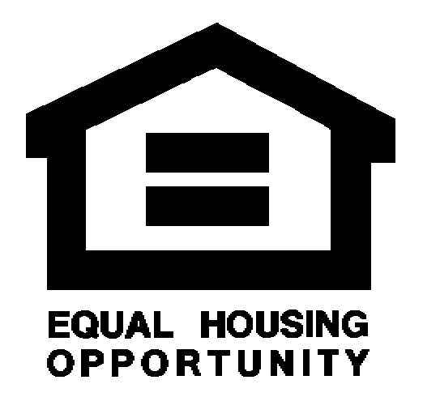

**All Closed Real Estate Transactions**

**January 1 – March 31,**

**2019**

Heartland Association

of Realtors

Data provided by Real Data Strategies, Inc., an independent consulting company. The above representation is based in whole or in part on data supplied by the referenced Multiple Listing Service and its member associations of REALTORS®. RE/MAX, the Multiple Listing Service, neither the member associations of REALTORS® guarantee or are in any way responsible for data accuracy. The data includes all reported listings sold and closed for the referenced area, county or city. The data may not reflect all real estate activity in the marketplace. This is not intended to solicit property currently listed with any other broker. This chart cannot be altered in any way; it must be shown in its original format. Any changes are strictly prohibited. Each RE/MAX office is independently owned and operated.

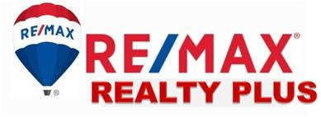

**Of Florida, Inc.**